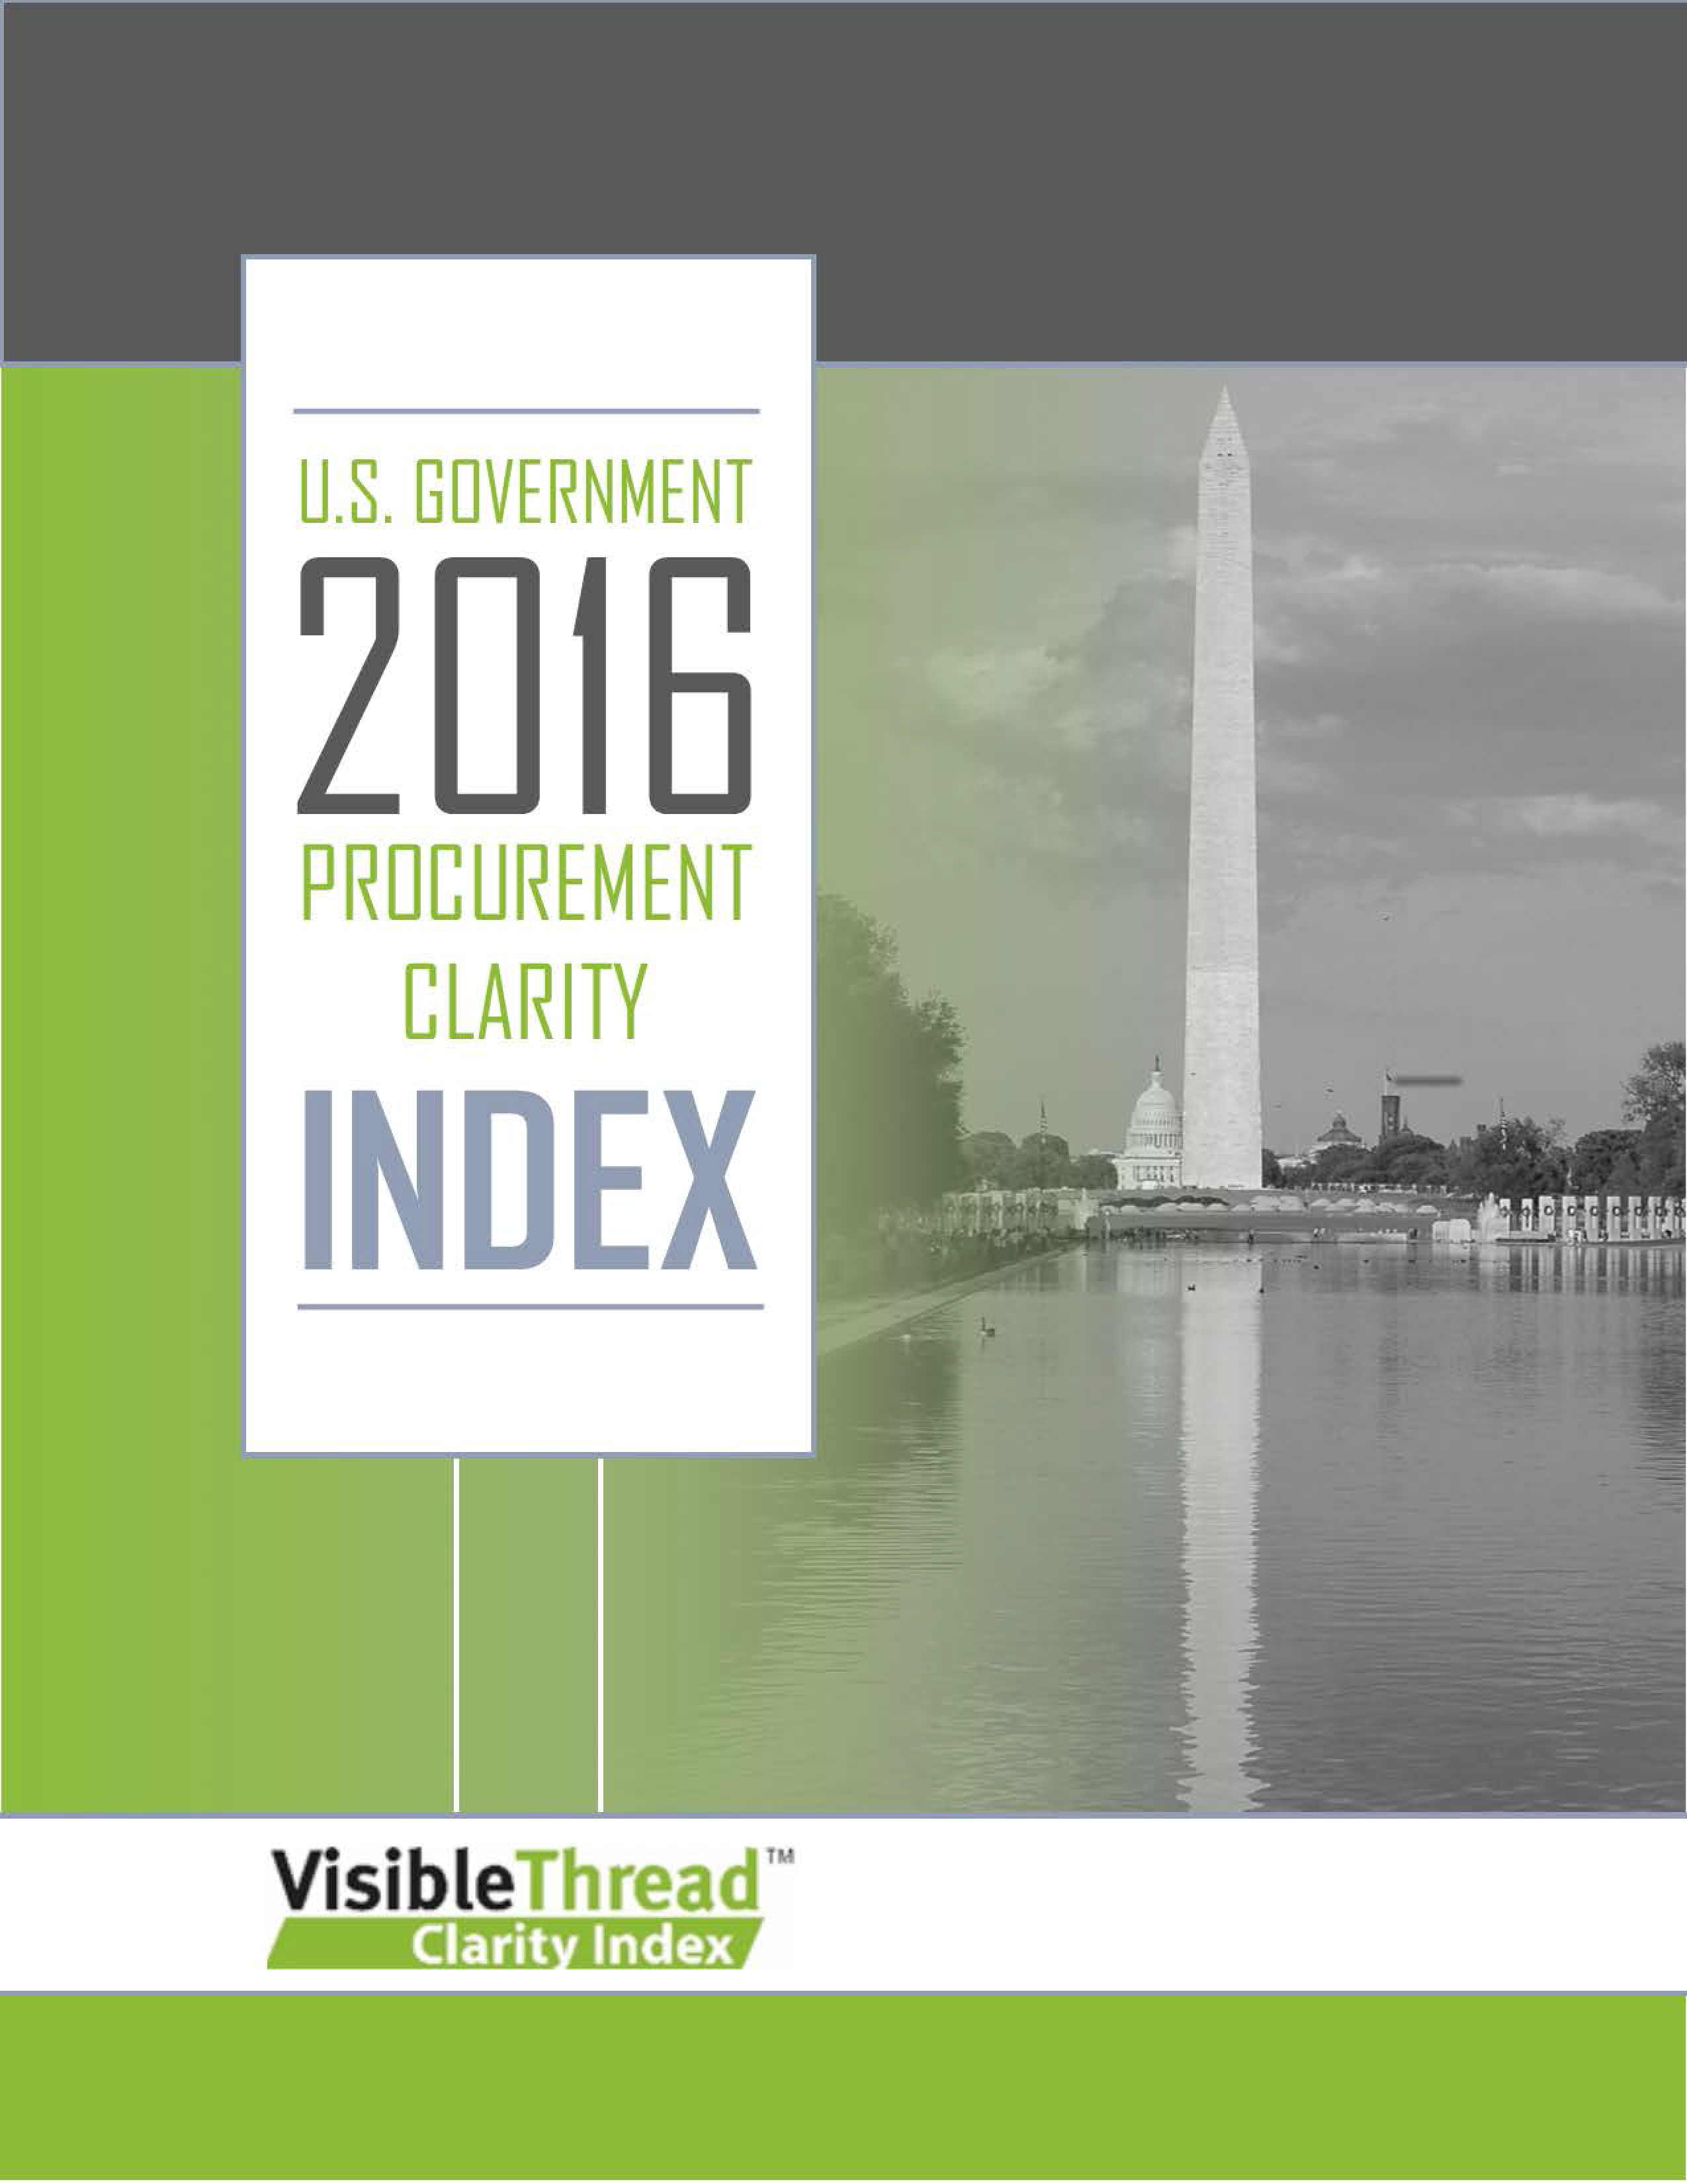

Executive Summary 2
Key Findings 3
Detailed Results Tables 6
Methodology – what are the metrics? 7
About VisibleThread 8

The VisibleThread Clarity Index, U.S. Gov. Procurement – 2016

Executive Summary
The internet is full of advice on how to write a quality response to a request-for-proposal (RFP). You won’t find nearly as much content on how to write the RFP itself. A good RFP helps its author collect comprehensive and comparable bids. Compliant responses help fuel evaluation of potential service providers and subcontractors. A clear and concise RFP helps bidding companies prepare proposals that address the requirements. Buyers with easy-to-understand RFPs enjoy a more efficient exchange with bidders. And they are more likely to find out of each respondent’s unique benefits and features.

Poorly executed procurement documents (RFIs, RFQs, RFPs and their related documents) create unnecessary costs for their authors. And the costs are not limited to the RFP selection process. A poorly written RFP may continue to create problems well after a provider is selected. Some of the largest contracts in the world result from RFPs issued by the U.S. government. Hence, the U.S. government assumes a large amount of risk when they issue RFPs of poor quality.

Clear writing in procurement documents helps government agencies achieve several objectives:

- Higher accuracy in matching suppliers to program needs: Poorly written RFP content may lead to the best supplier’s elimination based on technicalities. Avoid preventable errors through more clear instruction.
- Greater program performance: higher quality communication during the bidding process helps suppliers meet government program needs.
- Reduce costs: When bidders know what the government needs and how to respond, the process requires less time and fewer resources.

In March 2016, VisibleThread conducted an analysis of some of the largest RFPs issued by the U.S. government in 2015. The combined estimated value of these projects is in excess of $7 billion. The five RFPs selected for analysis were:

- General Services Administration (GSA) – Human Capital and Training Solutions (HCaTS)
- Health & Human Services (HHS) - Unified Program Integrity Contractor (UPIC)
- Health & Human Services (HHS) - Research, Measurement, Assessment, Design, and Analysis (RMADA)
- Air Force - Joint Range Technical Services (J-Tech II)
- Navy - Fielded Training Systems Support IV (FTSS-IV)

As our primary interest is in improving communication, we chose to analyze those areas of RFPs that have the greatest influence over the government’s ability to identify the best supplier for the job. Based on our focus, VisibleThread focused its analysis on three key areas of the RFP documents:

- Statement-of-work (SOW): These documents detail the scope of general nature of services or items required by the agency. (In other solicitations this might be a Performance Work Statement [PWS], or a Statement of Objective [SOO])
- Section L - “Instructions”: details the specific preparation requirements for bidders submitting applications. Bidders read this section carefully as misinterpretation can result in a disqualified proposal.
- Section M - “Evaluation Criteria”: communicates to bidders how the government plans to evaluate each bid and which criteria is most important to them. Understanding the weight attached to specific bid factors (price, materials, etc.) enables bidders to tailor their responses to demonstrate their fit for selection.

Based on this analysis, the following report details an Index of these RFPs based on clarity of written content. We measured each document set across these four dimensions:

- Readability – How readable is the content?
- Passive Language – Active Language communicates clearly. What proportion of sentences is passive?
- Long Sentences – What proportion of all sentences are too long?
- Word Complexity Density – Complex words make web pages hard to understand.

Our analysis suggests the following:

- Government contract procurement documents are generally poorly written.
- There are high degree of variability in the quality from agency to agency.
- Sections that have the greatest potential to influence government’s objectives are of the lowest quality.

We show a more detailed analysis later in this report.

Key Findings
Clear Language:
The following guideline definitions will help you understand the information we present in the Key Findings section:
- Readability – a score of 50 is considered acceptable, approximately an 8th grade reading level.
- Passive language – 4% or less is ideal.
- Long Sentences – 5% or less across all content is ideal.
- Complex language density – complex words/total words*100
Target levels are determined by published third party standards, such as those produced by the Flesch-Kincaid readability tests. The United States Navy developed the Flesch-Kincaid reading level test in the 1970s to improve the utility of technical documents, such as training manuals.
Complexity scores were based on the plain language dictionary published in conjunction with the Plain Language Act of 2010 and available at PlainLanguge.gov
You can find detailed definitions of ranking criteria in the Methodology section.

Overall Leaders
While the purpose of this study is not to assess individual agency performance, documents analyzed from the Department of Health & Human Services and the Navy RFPs performed best. HHS’ UPIC SOW document performed best among the respective sections.
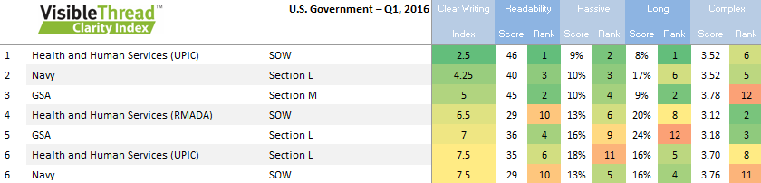
Across all three document classes, those analyzed from HHS UPIC and the Navy also had higher levels of quality. Of these two RFPs, the Navy’s document quality was more consistent, with a lower variance between sections.
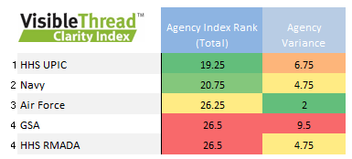
Among document classes, Section L documents were the easiest to read.. Section L documents also had the least variance in quality from among the sample. Section L documents detail how bidders should prepare their responses.
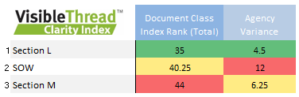
Room for Improvement:
It is important to note that not a single document in the entire analysis passed typical readability standards. From this perspective, all the RFPs reviewed could be improved.
- The average readability score across the Index was 32.9 – more than four grade levels higher than recommended for clear writing.
- Passive voice was present in 14% of sentences – more than 3x the recommended level for clear writing.
- 20% of sentences exceeded recommended levels for length – more than 4x recommended levels.
- Average complexity score was 3.67 across the Index – suggesting opportunities to simplify word choice across the document classes.
But, some documents were of poorer quality than others.
For quality, Section M documents had the worst scores in the Index. Readability scores average 31.4 across the document class. Passive voice levels were 14%, long sentences frequency was 21% and complexity was measured at 3.71. Sentences in Section M averaged 15.4 words per sentence, a score shared by the SOW documents.
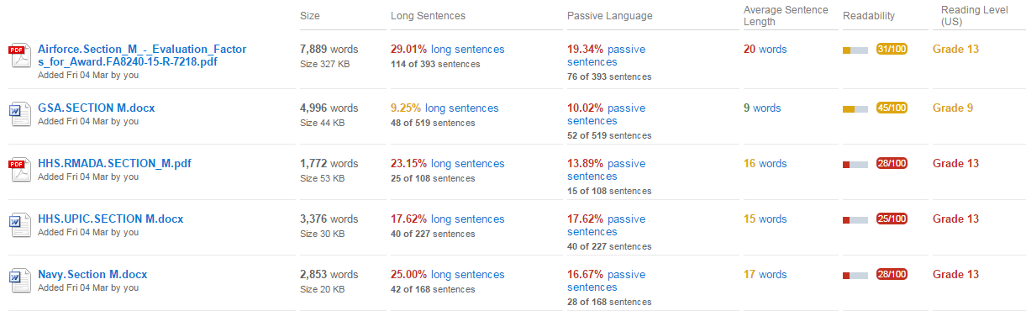
A strictly quantitative analysis can sometimes lack context. An example of the kind of content that produced such poor quality scores in the Section M class appears below:
“Overall Technical Rating: Technical proposals will be assessed on how well the Offeror's proposal meets the solicitation requirements and the risks associated with the Offeror's approach.
Offerors will receive one overall technical rating for the non-cost proposal evaluation factors which takes into consideration every aspect of their technical proposal and weighs the strengths, weaknesses, significant weaknesses, deficiencies, risks and their relative value to the Government.”
Takeaways:
  - Wide variability of quality between RFPs
Variability between the best and lowest scoring RFP content is high. Such a wide margin uggests that program requirements may influence complexity. Quality differences in documents produced by the same agency suggest teams have skill gaps. Variability may also indicate timeline pressures and inter-agency dependencies.
  - Agencies can dramatically improve clarity by focusing on certain metrics
Agencies can improve the quality of their documents by reducing the complexity of writing. Authors should replace long sentences with simpler, shorter alternatives. Word choice should be examined, ideally by cross-referencing content with a plain language dictionary. Agencies should also consider bulleted lists more to communicate criteria based content. Sentences of this type were large contributors to the poor quality scores.
  - Agencies are increasing their administrative burden by issuing RFPs of poor quality
Many people assume bidders feel the greatest burden from poorly crafted RFP documentation. But, agencies are creating higher costs for themselves by not monitoring quality more closely. Unreadable RFPs create lengthy question/answer response cycles for agency administrators. Multiple amendments need to be added to the RFP for clarification. And in some cases, an entire RFP may need to be reissued due to the confusion.
  - Agencies are increasing their operating costs by issuing RFPs of poor quality
- Proposal development costs are factors in bid pricing. So, agencies with unclear RFPs force the entire field of contractors into higher bids.
- Agencies miss out on quality contractors due to the federal bidding process. The large overhead, risk and complexity involved create barriers-to-entry for many otherwise qualified contractors. Unclear RFPs may deter qualified contractors with more efficient solutions from bidding.
- Agencies pay more for inferior services when the best contractors are disqualified for not following poorly worded instructions.
- Because of confusion in the bidding process, agencies frequently need to delay timelines. Altered timelines can result in higher charges from incumbents. And additional fees may be due to other firms already contracted and working on a project.

Detailed Results Tables
We show the full detailed tables below.
We color-code, green to red, each score in the Index. Green indicates best, red indicates worst. Color-coding helps us to understand sites where one or two specific scores may be dragging down the overall ranking. Flagging specific areas (for instance, passive language) pinpoints areas for improvement.

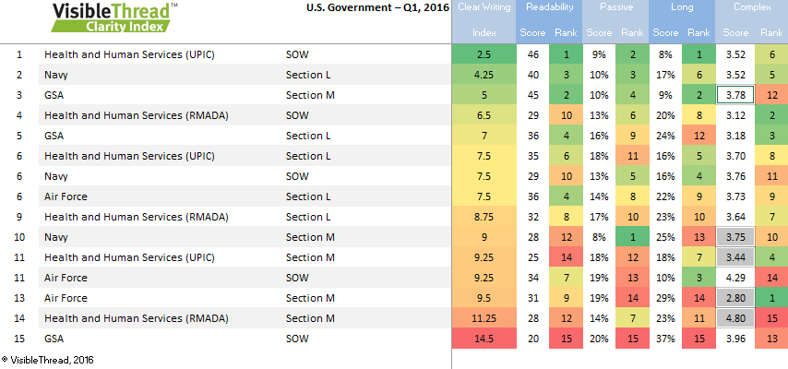

Methodology – what are the metrics?
- We analyzed the RFP documents in March, 2016.
- RFPs were randomly selected from public lists of the largest contracts issued by the U.S. Government in 2015
- We scanned more than 300,000 words of content using automated crawling techniques.
We calculated the index based on 4 metrics. Each metric contributes equally to the final score. The metrics are:
Metric |  | Formula
1. Readability
 | Readability ranges from 1 to 100. 100 is the top mark. If communicating with citizens, aim for at least 50.  This is based on the Flesch Reading Ease index. | (206.835 – (1.015 x Average Sentence Length) – (84.6 x Average Syllables per Word))
2. Passive Language
 | The % rating is the proportion of sentences with a passive construction. Passive language is where the subject acted upon appears before the verb. For example:  "Quality is monitored" vs. "We monitor quality"  If you use active voice, you will increase clarity & strength. You will also flush out the 'actor', i.e. who did the action? | (Passive Sentences / Total Sentences * 100)
3. Long Sentences
 | The % rating is the proportion of sentences that are longer than 25 words. Long sentences mask multiple concepts. Splitting up these sentences will result in a clearer message. | (Long Sentences / Total Sentences * 100)
4. Complex Word Density
 | The density rating is the proportion of complex words relative to the total word count. This scan looks for complex words/phrases based on Federal Guidelines. See http://www.plainlanguage.gov/howto/wordsuggestions/simplewords.cfm for the list scanned. Replacing complex words with simpler words helps your readers concentrate on your content. | (Complex Words/Total Words * 100)

About VisibleThread
VisibleThread helps executives in large organizations govern content quality with less cost and risk. Sales and marketing teams in diverse industries use our technology to improve many functions, including proposal development, contract review and brand audits. Our software finds brand compliance, poor readability and other issues in websites and documents. Unlike consumer-grade analysis tools, VisibleThread processes hundreds of documents and web pages in minutes. Fueled with greater organizational intelligence, customers drive efficiency and reduce cost across their organizations. For more information, visit www.visiblethread.com
For questions or if you want a specific sector index:
- For questions regarding VisibleThread technologies, email: sales@visiblethread.com
- For questions on the metrics or methodology, email: support@visiblethread.com
- For inquiries from members of the press or media, email: sangsland@anurastrategies.com

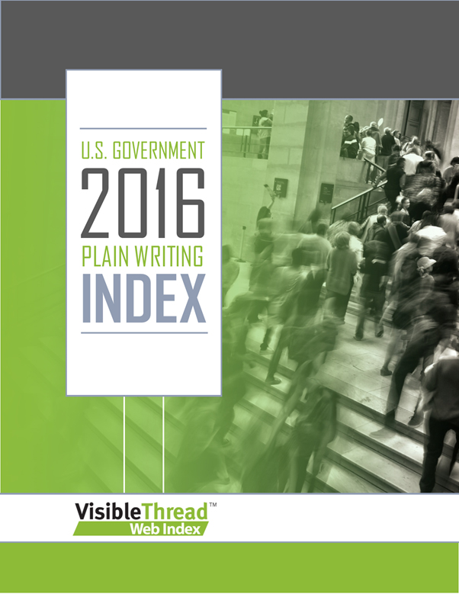 | U.S. GOVERNMENT PLAIN LANGUAGE INDEX 2016  VisibleThread released findings from its 2016 U.S. Government Index Report, a comparative study of the quality of content on a set of federal agency websites. The study, which also includes detailed comparisons to a benchmark 2011 report of the same agencies, finds that communication is worse today than it was five years ago.  GET IT HERE:  http://info.visiblethread.com/2016-US-Government-Index

__________________________________________________________________________________________

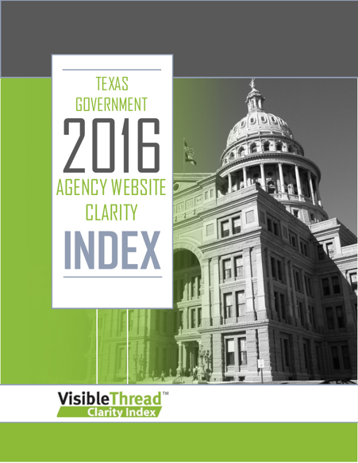 | TEXAS GOVERNMENT WEBSITE AGENCY CLARITY INDEX 2016  VisibleThread created an Index of 54 Texas Government agency websites based on clarity of written content. VisibleThread 2016 Texas Government Clarity Index explores how well agencies for the State of Texas communicate through their websites.  GET IT HERE:  http://info.visiblethread.com/Texas-Gov-Agency-Web-Clarity-Index-2016

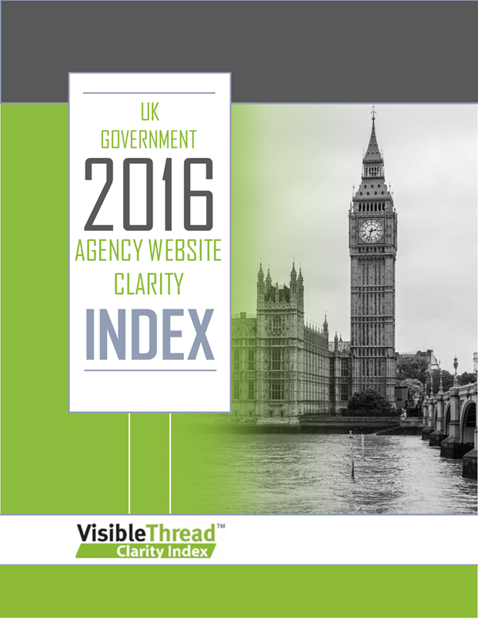 | UK GOVERNMENT WEBSITE CLARITY INDEX 2016  VisibleThread created an Index of 26 UK Government agency and departments websites based upon clarity of written content. The VisibleThread 2016 UK Government Clarity Index explores how well UK departments and agencies communicate through their websites.  GET IT HERE:  http://info.visiblethread.com/UK-Gov-Agency-Web-Clarity-Index-2016

__________________________________________________________________________________________

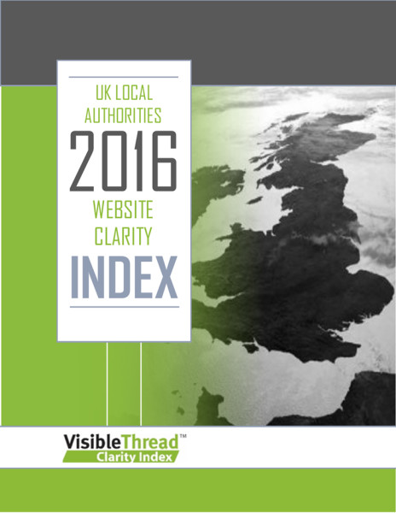 | UK LOCAL AUTHORITIES WEBSITE CLARITY INDEX 2016  VisibleThread analysed the web pages of 12 out of the 418 UK Local Authorities including County Councils, City Councils, and one Metropolitan District Council based upon clarity of written content. VisibleThread 2016 UK Local Authorities Clarity Index explores how well UK Local Authorities communicate through their websites.  GET IT HERE:  http://info.visiblethread.com/UK-Local-Authorities-Website-Clarity-Index-2016

